

***Artificial Intelligence (Lab)***

***Assignment - 2***

**Name:**

Ali Maqsood.

**Roll no:**

SU92-BSAIM-F23-050.

**Department:**

Software Engineering Department.

**Program:**

Artificial Intelligence.

**Section:**

BSAI-3A

**Question # 1:**

Today's project is actually a very common interview question, which revolves around a childhood counting game called Fizz Buzz.

**Explanation:**

In this code we have created a fizz buzz game. It will explain the rules first after that the program itself will guess a random number from 0-50 using the random library. Once the number is guessed the user will be asked to enter fizz, buzz or fizzbuzz. Based on the user’s choice, the answer will be checked and it will go on for 5 rounds. In the end, the user will be able to see the score they achieved. There is a small catch in the game that after first round the program will add the new random guess with the previous one and the user will have to keep this in mind in order to win the game.

**Code:**

import random

def mini1():

    print("Welcome to Fizz And Buzz.")

    print("There will be 5 rounds in total.")

    print("Rules:")

    print("\t 1. If the number is divisible by 3, Enter Fizz.")

    print("\t 2. If the number is divisible by 5, Enter Buzz.")

    print("\t 3. If the number is divisible by both 3 and 5, Enter FizzBuzz.")

    print("\t 4. If the number is not divisible by 3 or 5, Enter None.")

    times=1

    a1=0

    while times<=5:

        guess=random.randint(0,50)

        a2=a1

        a1=guess

        print(f"Guess: {guess}")

        user_guess=input("Enter your guess: ").lower()

        if user_guess=="fizzbuzz" and (a1+a2)%3==0 and (a1+a2)%5==0:

            print("Correct")

        elif user_guess=="fizz" and (a1+a2)%3==0:

            print("Correct")

        elif user_guess=="buzz" and (a1+a2)%5==0:

            print("Correct")

        elif user_guess=="none" and (a1+a2)%3!=0 and (a1+a2)%5!=0:

            print("Correct")

        elif user_guess != "none" and user_guess != "fizz" and user_guess != "buzz" and user_guess != "fizzbuzz":

            print("Invalid Input! Game Over ~~ XD")

            break

        else:

            print("Wrong")

        times+=1

mini1()

**Output:**

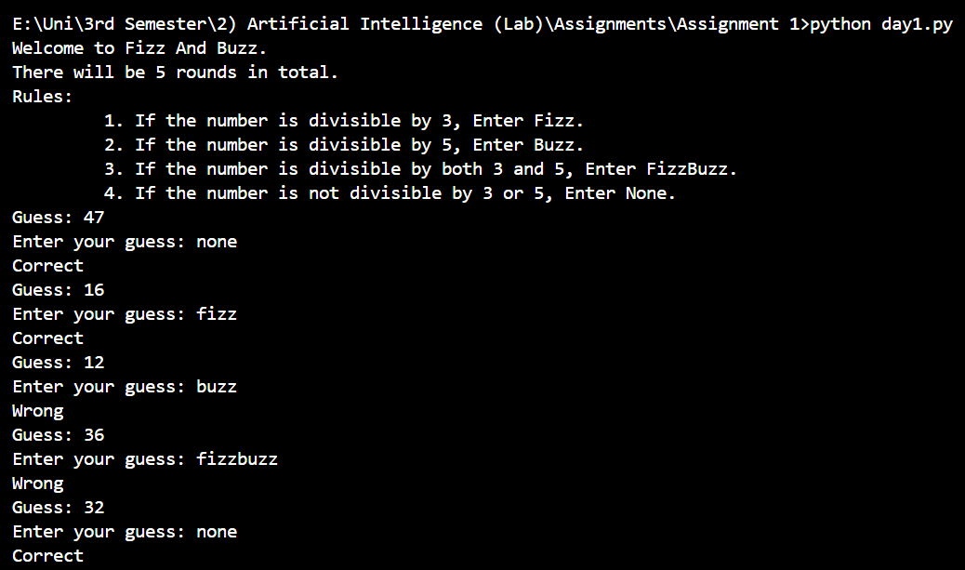

**Question # 2:**

For this project, your program should do the following:

Calculate the average budget of all movies in the data set.

Print out every movie that has a budget higher than the average you calculated. You should also print out how much higher than the average the movie's budget was.

Print out how many movies spent more than the average you calculated.

If you want a little extra challenge, allow users to add more movies to the data set before running the calculations.

**Explanation:**

This is a simple calculation program. It already have a predefined list in which it contains tuples as each element and in each tuple it contains the movie name and budget. The user can also decide to add some movies based on the user choice. Once the user adds the movies after that the program will calculate the average budget of all the movies including the pre-defined as well as the user entered. Once the average budget is calculated, the program will print all the movies that are above average budget.

**Code:**

def mini2():

    movies = [

    ("Eternal Sunshine of the Spotless Mind", 20000000),

    ("Memento", 9000000),

    ("Requiem for a Dream", 4500000),

    ("Pirates of the Caribbean: On Stranger Tides", 379000000),

    ("Avengers: Age of Ultron", 365000000),

    ("Avengers: Endgame", 356000000),

    ("Incredibles 2", 200000000)

    ]

    input1=int(input("Enter the number of movies: \n"))

    for i in range (input1):

        movie_name=input("Enter the movie name: ")

        movie_budget=int(input("Enter the movie budget: "))

        print("\n")

        movies.append((movie_name,movie_budget))

    print("Calculating Average Budgets.....\n")

    total=0

    for i in range(len(movies)):

        total = total + movies[i][1]

    avg=total/len(movies)

    print(f"The average budget of the movies is {int(avg)}\n")

    print("The movies that are above Average Budget:\n")

    total_abv_avg=0

    for i in movies:

        if i[1] > avg:

            print(f"Name: {i[0]}.")

            print(f"Budget: {i[1]}.\n")

            total_abv_avg+=1

    print(f"Total number of movies above average budget: {total_abv_avg}.")

mini2()

**Output:**

